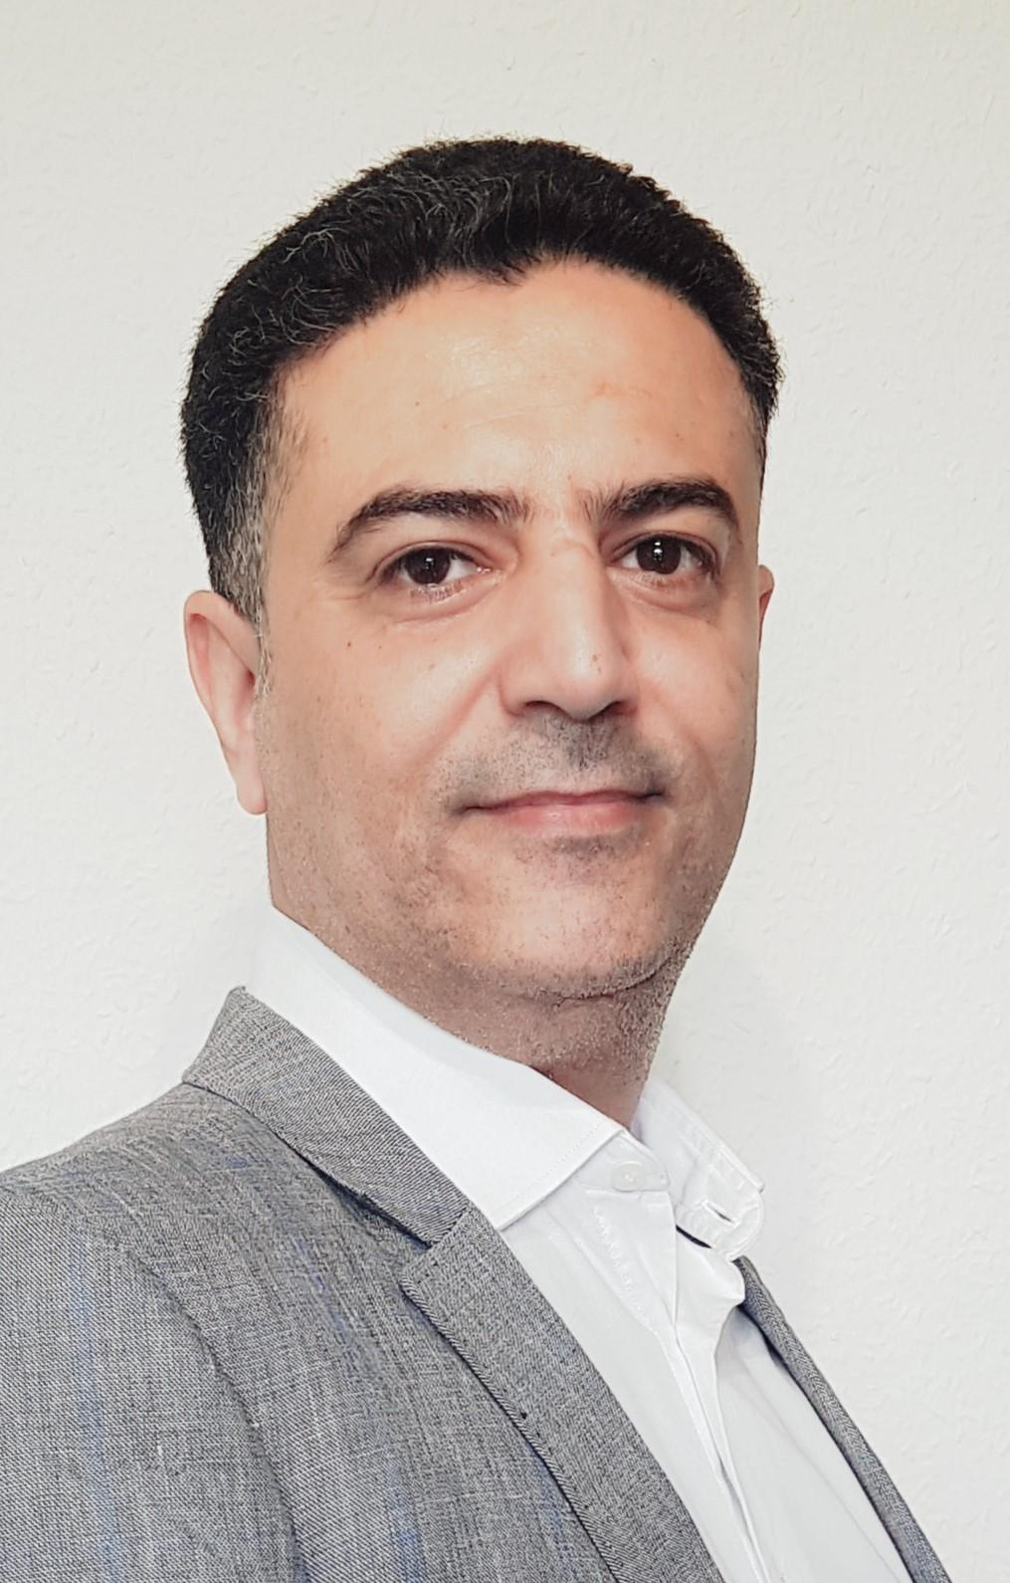

*An articulate, focused and capable accounting professional with versatile work experience in accounting at different levels, including the roles of general accounting, budgeting & planning, management reporting, cost controls, and financial management analysis. Looking for an opportunity to continue doing what I love, in a challenging, but friendly environment.*

**WORK EXPERIENCE**



**Canadian Nexen Petroleum East Al Hajr – Sana’a**

Jan, 2014 – Apr, 2015 **Sr. Accounting Specialist**

* Month End, Quarter End and Year End Accounts Closing.
* Inter-Company Balances.
* SOX Reconciliations.
* A/R & A/P Balances.
* Bank Reconciliations (Canada, USA, and Yemen).
* Point of Contact with International Accounting Group in Calgary.

Apr, 2012 – Jan, 2014 **Sr. Audit & Budget Specialist**

* Annual Budget Preparation.
* Month End, Quarter End and Year End Financial Reports.
* Annual Cost Recovery Audit & Joint Venture Audit.

Nov, 2008 – Apr, 2012 **Sr. Cost Accountant – OPEX (back to back position)**

* Month End Accounts Closing & Financial Reports.
* Participate in the Annual Budget Preparation.
* Third Party Facility Usage Charge Analyst & Dead Storage Calculations.
* Third Party Balances.
* Monthly OPEX Cash Call.

Aug, 2007 – Nov, 2008 **Business Analyst – G&A**

* Month End Accounts Closing & Financial Reports.
* Participate in the Annual Budget Preparation.

Oct, 2006 – Aug, 2007 **General Accountant**

* Bank Reconciliations.
* Travel Expenses.

**US Embassy – Sana’a**

Jun, 2003 – Oct, 2006 **Budget Analyst**

* Managing financial resources for four programs.
* Participate in the Annual Budget Requests Preparation.
* Periodic Budget Review & Status of Fund.
* Point of Contact with the Financial Service Center.

**EDUCATION**



2006 Obtained a bachelor’s degree in **Accounting** from Sana’a University, College of Commerce & Economy (Sana’a, Yemen).

**TRAINING COURSES**



2014 **Fast Closing Month End & Year End Accounts**

Istanbul, November 23 - 27

2008 **Certified Budget Planner “Budgeting, Planning & Management Reporting”**

Kuala Lumpur, November 10 - 14

2004 **Accounting One** training course

Paris, July 05 - 09

2003 **Accounting System LAN-SPFMS 9.0.0**

Bangkok, August 18 - 22

**LANGUAGES**



* Arabic Native
* English Very good (written and spoken)
* German Good (B1)

**SKILLS**



* SAP FICO & SAP BW User for 9 years.
* Microsoft applications & Outlook.
* Strong organization skills, problem solving, detail orientation, the ability to multitask, meet deadlines and prioritize work.
* Great oral and written communication skills.
* Experience in communicating with senior and executive management.